|  |  |
| --- | --- |
|  | **2013** |
|  | ArbitraryY  Nick Squires |

|  |
| --- |
| **Secrets of the Universe [SOTU] System Description Document (SDD)** |
| Requirements, Software/Hardware Architectures, Software/Hardware Maintenance, Installation, Operation Instructions |

Contents

System Requirements 2

Hardware 3

Architecture 3

System Schematic 3

Hardware Listing 3

Platoon Hardware System 4

Hardware Components Overview 4

Raspberry Pi 4

LED Driver Board 5

Arduino and Protoshield 6

Range Sensor 7

LCD Screen 8

System Assembly 9

Platoon Hardware Assembly 9

Software 14

Development Environment 14

Architecture Overview 16

Maintenance 17

Developer Guide 17

Coding Guide 17

OSC Architecture 18

User Guide 18

Software Upgrades 18

pltnUpdate.py 18

System Maintenance 19

Starting the system 19

Remote Connections 19

# System Description

“Secrets of the Universe” is an interactive art installation and musical performance which explores various topics in physics and cosmology.

“SOTU” is the underlying computing hardware and software system which functions as the exhibitions brain. It drives all of the user interactions

# System Requirements

Controllers will be built for each painting. The controllers need to function in the following 3 ways:

1. Playing the paintings: Controllers must accept MIDI/OSC commands via a WiFi network and translate those messages into commands that will activate the LEDs
2. Range Sensor Activation: Controllers must have a range sensor attached that will activate the LEDs based on predefined distances a user stands from each painting. There will be a predefined color scheme associated with each range
3. Web Application: Controllers must run a webserver and a web application that will allow a user that is connected to the same WiFi network, to activate and manually modify the color schemes using any device with a web browser. This will be useful once the paintings are sold to allow their user to modify colors as they please
4. Each painting shall be able to be controlled individually and act as independent computing unit
5. Each unit accessible from multiple remote protocols
6. OSC infrastructure
7. Control Center

# Hardware

## Architecture

### System Schematic

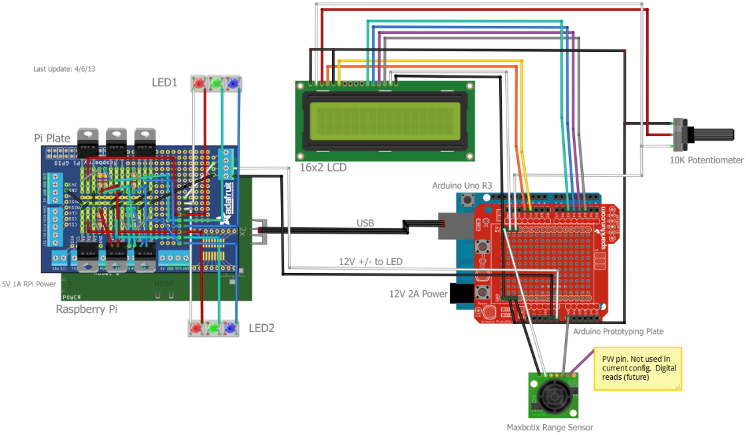

### Hardware Bill of Materials (BOM)

#### Microcontrollers

* 1 x Raspberry Pi Model B
* 1 x Arduino Uno R3

#### LED Driver Board

* 6 x TIP 120 Transistor
* 6 x 470 Resistor
* 1 x Adafruit Pi Plate

#### Peripherals

* 1 x Edimax USB 802.11n/g/b WiFi Dongle
* 1 x 4GB SDHC Card Class 4 (already attached to RPi)
* 1 x 10K Potentiometer
* 1 x Arduino Protoplate
* 1 x Maxbotix LV-EZ1 Range Sensor
* 1 x 16x2 LCD Display
* 2 x LED Strips
* 1 x 12V, 2A Power Supply (Arduino)
* 1 x 5.25V, 1A Power Supply (Raspberry Pi), Micro USB-B input

# Hardware System

The following is an overview of each hardware components and their associated assembly instructions

## Hardware Components Overview

The Platoon hardware system consists of the following components

* 1 x Raspberry Pi Model B
* 1 x USB WiFi Dongle (already attached to RPi)
* 1 x 4GB SD Card (already attached to RPi)
* 1 x LED Driver Board
* 1 X Arduino Uno R3
* 1 x Arduino Protoboard (already attached to Arduino)
* 1 x 2’ USB-A to USB-B Cable
* 2 x 12V/GND wire (one black, one white)

### Raspberry Pi

The Raspberry Pi is the brain of the system. It is running the Raspbian Wheezy Linux Operating System and provides the following functionality:

1. Webserver - Host web applications (web LED controller, painting descriptions`)
2. OSC Server – Accept and translate OSC messages from an OSC client to perform LED manipulations, RPi functions,
3. Remote Access – SSH and VNC terminal access. Allows for remote software updates to RPi and Arduino
4. WiFi - WEP/WPA/WPA2 Network access
5. LED Controls - Software PWM to control brightness of LEDs. Change colors via webserver, OSC, or range sensor (sent over serial via Firmata from Arduino)

Below is an overview of the Raspberry Pi components you will be interested in.

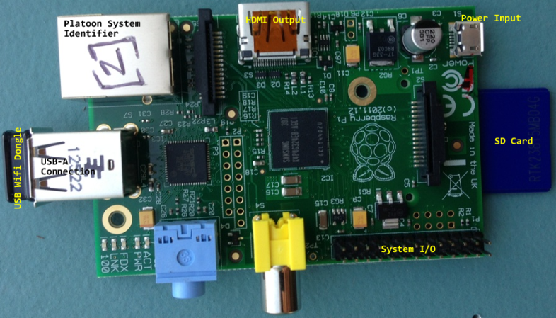

Figure – Raspberry Pi Components

* Platoon System Identifier – Values range from [1] – [6] according to the associated painting
* HDMI Output – Plug in a monitor using an HDMI cable to get screen access to Raspberry Pi
* USB Wifi Dongle – WiFi access
* SD Card – Platoon system file storage and Raspbian operating system
* System I/O – System Input/Output pins. Where the LED driver board sits
* Power Input – 5.25V, 1A Micro USB-B Input

### LED Driver Board

The LED driver board is a circuit of transistors and resistors that act as power gates for the 12V LED strips. There are two circuits, one for each LED strip, and are connected via a common system ground.

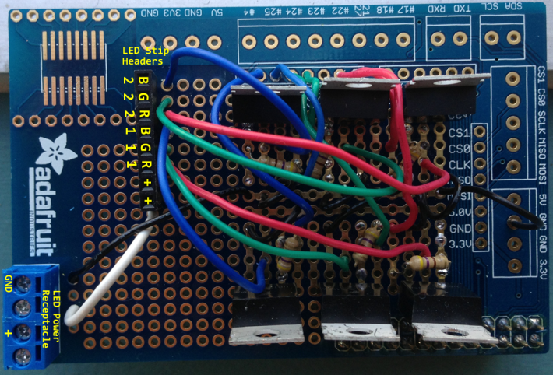

Figure - LED Driver Board Overview

* LED Power receptacle – Power and common ground from the Arduino
* LED Strip Headers – Connections for LED strips
  + Rx, Gx, Bx, - Red, Green, Blue, pinouts for strip x (1|2 since 2 strips).
  + + - 12V to LED strip

### Arduino and Protoshield

The Arduino and its attached circuit board (Protoshield) provides the following system functionality:

1. Distance Measurements – Uses the range sensor to detect and calculate a user’s distance from the sensor and sends data via (USB) serial connection to Raspberry Pi
2. 12V/5V Power Routing – Power the LED driver board, LCD screen, and range sensor
3. LCD Control - Display painting names

Below is an overview of the Arduino and the Arduino circuit board:

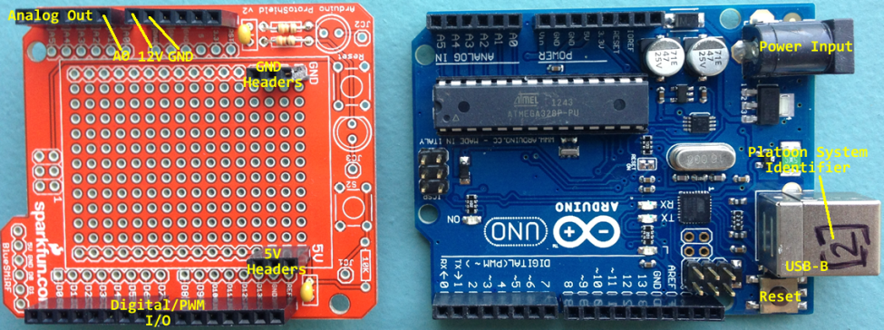

Figure - Arduino and Circuit Board

* Analog Out – Analog output pins. A0 is used for range sensor data
* 12V/GND – Supplies 12V output and common ground to LED driver board
* Digital/PWM I/O – Digital and Pulse Width Modulation (PWM) I/O pins. Provides data to LCD display.
* 5V/GND Headers – Provides power and common ground to the range sensor and LCD display
* Power Input – 12V 2A power supply connector
* Platoon System Identifier - Values range from [1] – [6] according to the associated painting
* USB–B – USB serial communications with Raspberry Pi
* Reset – Restart the Arduino

### Range Sensor

The range sensor is used to determine a user’s distance from the painting. It can use either Analog or Digital (PWM) to report distances. Below is a diagram of pertinent connections:

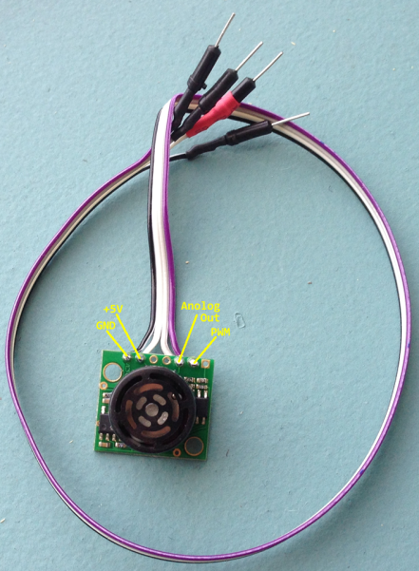

Figure - Range Sensor

### LCD Screen

The Arduino takes the hardcoded value of the painting name that is embedded in the pltnmataX.ino (X is a paintings associated system identifier) code and outputs it to the LCD screen. The LCD and its pertinent connections are shown below

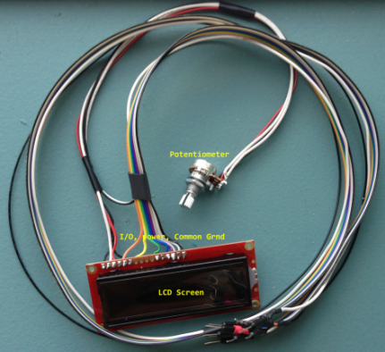

Figure - LCD Screen

* Potentiometer – 10K variable resistor controls the LCD brightness
* LCD Screen – Painting name output
* I/O, Power, Common GND – Input/Output, 5V power, and common system ground connections (detailed schematic provided in “Connecting LCD to Arduino” section)

# System Assembly

## Platoon Hardware Assembly

1. Attach LED driver board to the system I/O pins on the Raspberry PI

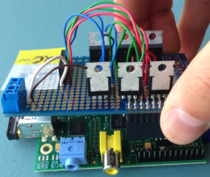

Figure - LED Driver Board Attachment to RPi

1. Connect the black (GND) and white (+12V) power wires to the LED power receptacle on the LED driver board; make sure to connect the side opposite the male pin to the receptacle. Loosen the screws on the top of the receptacle, insert the wires, and then tighten screws down until they are securely fastened.

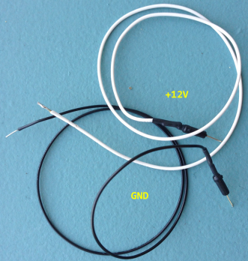

Figure - Power/GND Wires

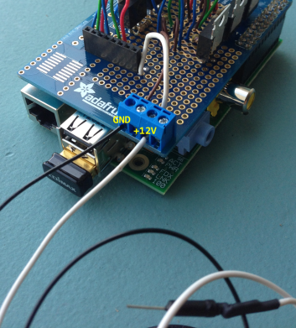

Figure - Power Wire Receptacle Placement from RPi to Arduino

1. Connect the male header end of the GND/12V wires to the 12V (called RAW on Protoshield) and GND female headers on the Arduino Protoshield as shown below:

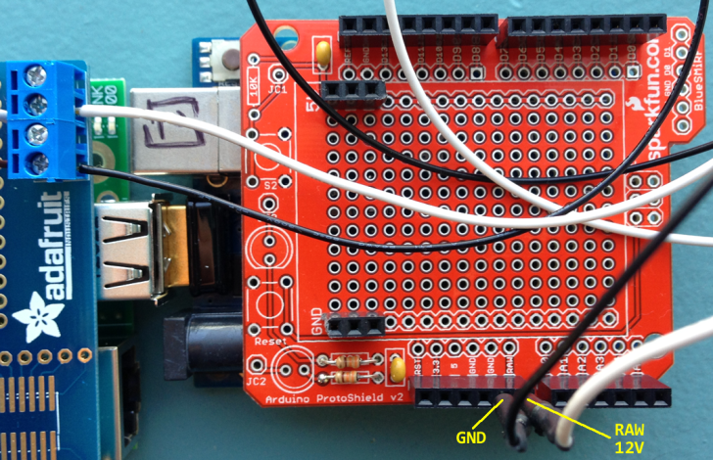

Figure - LED Driver Board Power Wires from Raspberry Pi to Arduino

1. Connect the USB-A/USB-B cable from the Raspberry Pi to the Arduino as shown below:

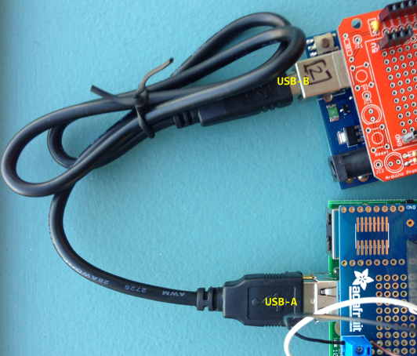

Figure - USB (serial) Connection between Arduino and Raspberry Pi

1. Connect the LCD to Arduino Protoshield per the schematic below

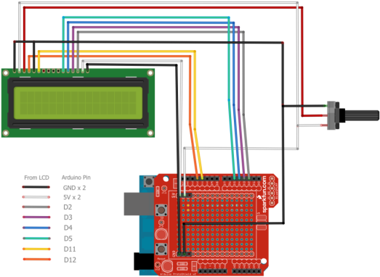

Figure - LCD --> Arduino Connections

1. Connect the range sensor per the diagram below. Note that the purple wire (PWM) is not used in the current configuration. Make sure you securely fasten the header away from any connections on the Protoshield as it may short the connection and affect the reliability of the readings

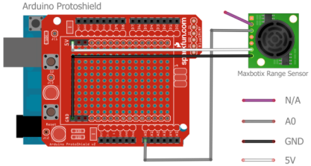

Figure - Range Sensor Connection to Arduino Protoshield

1. Connect the LED strips to the LED driver board per the schematic below

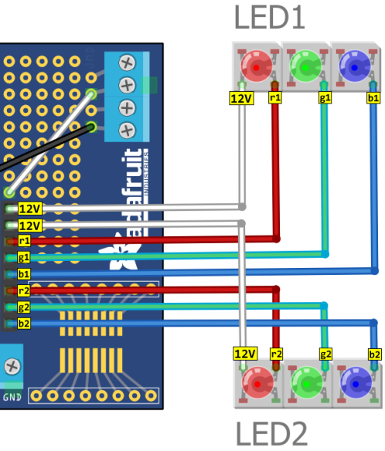

Figure - LED Strip Connection to LED Driver Board

1. Connect the 12V power Supply to the Arduino. The power light on the Arduino (visible through the Protoplate) will be lit red. The LCD screen backlight becomes visible immediately. After 5 – 10 seconds the LCD screen should display the painting name. If it doesn’t adjust the potentiometer all the way to the left until boxes are illuminated in each of the 32 character positions on the display. Slowly adjust the potentiometer to the right until the painting name is visible. If you go too far the right the letters will disappear.

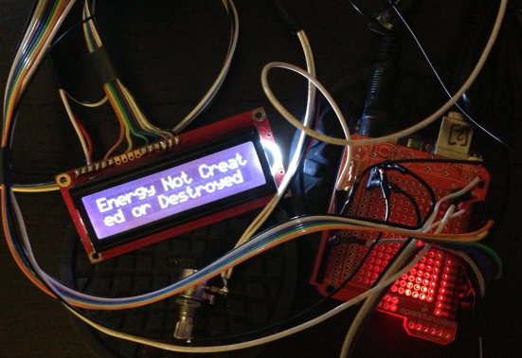

Figure - 12V Power Supply to Arduino

1. Connect the 5.25V 1A power supply to the Raspberry Pi. You will see the RPi red power LED lit up and the WiFi USB dongle flashing blue.

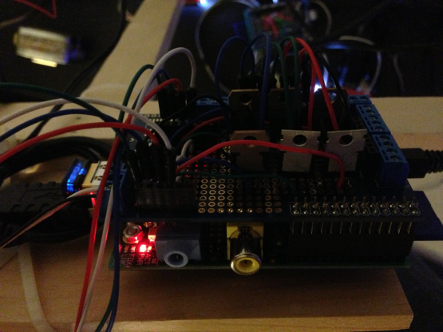

Figure - RPi Power Plugged in

# Software

## Development Environment

The following languages, Protocols and Software tools are used throughout the Platoon software system:

* Operating Systems
  + Raspbian Wheezy
  + Arduino firmware 0022
* Languages
  + Arduino – Range Sensor and LCD
  + Python – Software PWM, pyFirmata (Range sensor readings)
  + PERL – OSC Server
  + PHP – Web Applications
* Protocols
  + Open Sound Control (OSC)
  + MIDI
  + Serial (pyFirmata)
  + HTTP
  + SSH
  + TCP/UDP
* Tools
  + Fritzing – Circuit design
  + TouchOSC Editor – Build OSC User Interfaces

## Architecture Overview



Figure - Platoon Software Architecture

## Maintenance

# Developer Guide

This guide will help a developer develop within the SOTU system

## Coding Guide

Control of the components in the system have been enumerated using the Python class structure shown below. Details about the classes and methods can be found in the SOTU Developer Guide.

* OSC.py – Python class for creating Simple OSC Servers and Clients.
  + More info here: <https://gitorious.org/pyosc>
* rsDistance.py – Range sensor readings
* CommonLED.py – Common LED functions used for one off operations or in conjunction with more complex schemes
* LED.py – LED effects related to range sensor operation
* Effects.py – Create and activate effects on the LEDs
* pltnGpio.py – Class to access RPi GPIO pins
* Pblstr.py – Wrapper class for pi-blaster

## OSC Architecture

The OSC server (OSCServer.py) is a script written in Python that runs as a Linux service (oscServer) on the Raspberry Pi. It is based primarily on the OSC Python library and hence has a message handler + callback architecture that can be used to build custom functions and programs for command and control of any part of the system (range sensor, LEDs, Raspberry Pi Services, etc).

When the oscServer service is started, it will listen on a specified port (hardcoded in OSCserver.py as port 4567 in the code) for messages from any given client.

The current functions that are available for use with an OSC client are shown below:

* **LED – LED Functions**
  + **/pltn/led allOff** - turn all LEDs off
  + **/pltn/led allOn** - turn all LEDs on (white)
  + **/pltn/led (r1|g1|b1|r2|g2|b2) (value) (solid|flashFade|flash)**
    - (r1|...|b2) = color+stripNumber
    - (value) = PWM representation of brightness from 0 – 1
    - (solid|flashFade|flash)
      * solid = turn color on
      * flashfade = turn color on then fade out
      * flash = turn on then off
* **Raspbian Services** – Start and stop Linux services. Allowed services are defined in the array allowedSrvcs in OSCserver.py
  + **/pltn/srvc (pi-blaster|rangeSensor|ssh|pltnAgent) (start|stop)**
    - (start|stop) = Start or stop the given service
* **Raspberry Pi** - Reserved for other functions specific to the RPi (non services)
  + **/pltn/rpi off (authz_key)** - Safely shutdown the RPi. Need to provide the appropriate (authz_key)
* **Heartbeat** – Send health status to remote OSC server
  + **/pltn/heartbeat (hostname) (serviceName) (0|1) (PID)**
    - (hostname) = hostname of the RPi
    - (serviceName) = the service reported about
    - (0|1) = Running? No|Yes
    - (PID) = The Linux PID for that service

# User Guide

## Software Upgrades

The current version of the pltn software resides in a Git repository called pltn.git. To check out the latest version use http://

### pltnUpdate.py

1. List available versions
2. List installed versions
3. Uninstall version X
4. Install version Y

## System Maintenance

## Starting the system

rangeSensor, pi-blaster, OSC server, custom schemes

## Remote Connections

* SSH Access
* VNC Server